# a)

%% (a)

clc;

clear all;

close all;

clear workspace;

T=0.01;

fs=1/T;

t=[0:T:1-T];

x=sin(2*pi*5*t)+cos(2*pi*3*t);

figure(1)

subplot(321)

stem(x)

X=fft(x);

absX=abs(X);

subplot(322)

plot([absX absX absX]) % this plots the FT between omega=0 and omega=6pi-1/T

p=zeros(1,length(x));

p([1:4:length(x)])=ones(1,length(x)/4); %This redefines the sampling rate as 4

y=x.*p;

subplot(323)

stem(y)

Y=fft(y);

absY=abs(Y);

subplot(324)

plot([absY absY absY])

z=y([1:4:length(y)]);

subplot(325)

stem(z)

Z=fft(z);

absZ=abs(Z);

subplot(326)

plot([absZ absZ absZ])

# b)

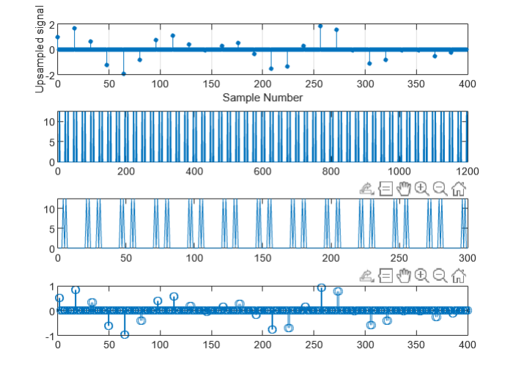

Was unable to get a graph that was easier to read.

%% (i)

z = upsample(z,16);

figure

subplot(411)

stem(0:399,z(1:400),'filled','MarkerSize',3)

grid on

xlabel('Sample Number')

ylabel('Upsampled signal')

%%(ii) Applying Fourier Transform

Z=fft(z);

absZ=abs(Z);

subplot(412)

plot([absZ absZ absZ])

%% (iii)Applying Lowpass filter with cut off frequency of 2 Hz

b=fir1(1,2/(fs/2),'low');

y=filter(b,1,z)

Y=fft(y);

subplot(413)

plot([absY absY absY])

%% (iv) Applying Inverse Fourier Transform

y=ifft(Y)

subplot(414)

stem(y);